***5 Take a screen shot of the terminal screen. Add that to your document.***



***12 How long the scan takes depends on the amount of data in your directory being scanned. At the end you should receive a summary of the results. Take a screen shot of the terminal screen. Add that to your document***

***16 Take a screen shot of the terminal screen. Add that to your document.***

***21 Take a screen shot of the summary on the terminal screen. Add that to your document.***

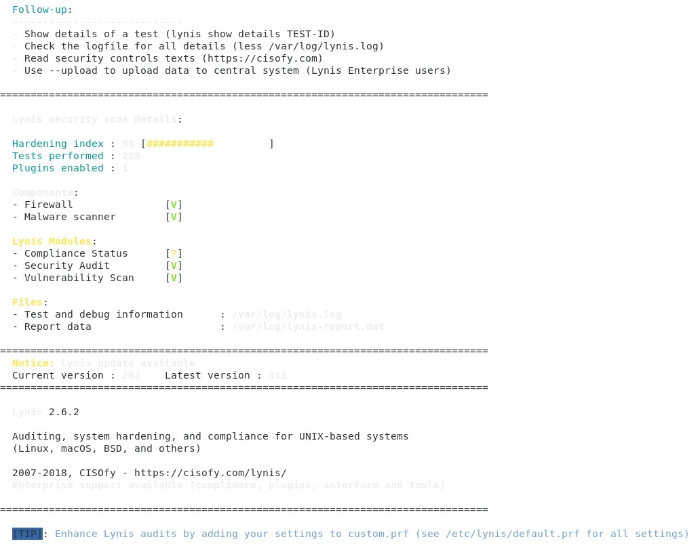

***24 Take a screen shot of the summary on the terminal screen. Add that to your document.***

***Reflection Questions***

***1 What is the function of freshclam***? Freshclam updates the ClamAV virus database with the latest virus signatures to ensure effective detection of new threats***.***

***2 By default Clamav runs in what mode?*** daemon mode

***3 What is the difference of performing a Lynis audit with and without the –check-all option***? Running Lynis with the --check-all option performs a comprehensive security audit, including all available tests, while without it, only a subset of standard tests is performed***.***